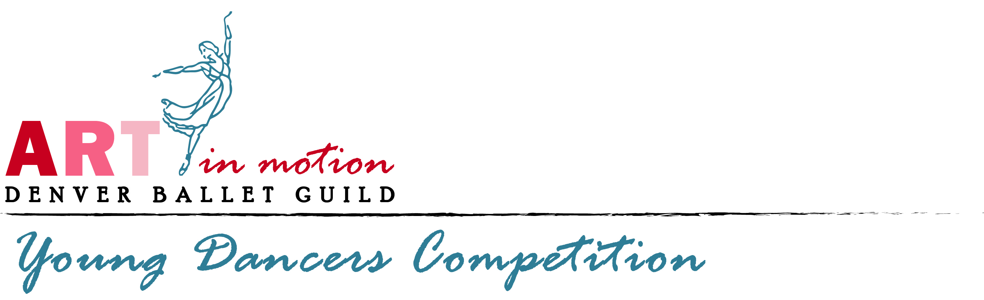

February 6, 2020

Dear Studio Owner, Artistic Director, or Instructor,

Denver Ballet Guild is in the process of updating records on the Young Dancers Competition, now in its 37th year! Our historian needs your very valuable input. Many fine young dancers have been awarded performance awards through our competition, and have continued their dance education through further training at respective studios and summer intensive programs at a variety of respected schools. Some have embarked upon professional careers/contracts with companies, pursued college degrees, and others have entered choreographic circles, or the academic and health wellness fields. Some have even begun the dauntingly responsible, yet rewarding task of teaching/training young dancers.

We would like to have as much update on your particular “star or stars” as teachers or parents can give us. Please fill out and return the bottom half of this form to the address below or bring it to the check-in desk at the Young Dancers Competition this March 2020.

Thank-you for your help!

Name of Student

Year of Award (approximate)

Finalist placement (1st, 2nd, 3rd, etc…)

Dancer Update:

Parent/Dancer Contact phone # for further info:

Copy form as needed and return to: Monica Hill, 5109 E. Maplewood Pl., Littleton, CO 80121

